**20CS2032L – MACHINE LEARNING TECHNIQUES**

**URK22AI1048**

|  |  |
| --- | --- |
| **Ex. No. 06** | **AGGLOMERATIVE CLUSTERING ALGORITHM** |
| **06.07.2024** |

# Aim

Develop agglomerative clustering models to cluster the given dataset using the scikit-learn.

# Description

Hierarchical clustering is a type of clustering algorithm used in unsupervised machine learning to group similar data points together in a hierarchical tree-like structure, also known as a dendrogram. The algorithm starts by treating each data point as a separate cluster, and then iteratively merges the closest pair of clusters until a stopping criterion is met.

### Hierarchical clustering can be performed using two approaches:

**Agglomerative hierarchical clustering**: In this approach, each data point is initially considered as a separate cluster and then, at each step, the two closest clusters are merged into a larger cluster. This process is continued until all data points belong to a single cluster. This is a bottom-up approach.

**Divisive hierarchical clustering**: In this approach, all data points are initially considered as belonging to a single cluster, and then at each step, the cluster is recursively split into smaller clusters based on some distance metric, until each cluster contains only one data point. This is a top-down approach.

**Dendrogram**: A Useful Tool for Summarizing Similarity Measurements

* Min Distance: Minimum distance of two points.
* Max Distance: Maximum distance of two points.
* Group Average: Average of distance between every two points of the cluster.
* Ward’s method: Similarity is based on the increase in square when two clusters are merged.

Ex. 06| Agglomerative Clustering Algorithm

1

**20CS2032L – Machine Learning Techniques**

**URK22AI1048**

# Source Code

### Pre-process the data and fill the missing values and apply normalization

import pandas as pd import numpy as np

from sklearn.preprocessing import StandardScale data=pd.read_csv(hopping-data.csv') data.fillna(data.mean(), inplace=True)

scaler = StandardScaler()

data_normalized = scaler.fit_transform(data.select_dtypes(include=[np.number]))

data_normalized_df = pd.DataFrame(data_normalized, columns=data.select_dtypes(include=[np.number]).columns)

non_numeric_cols = data.select_dtypes(exclude=[np.number]).columns

data_normalized_df = pd.concat([data_normalized_df, data[non_numeric_cols].reset_index(drop=True)], axis=1)

print(data_normalized_df.head())

### Apply label encoding to convert the categorical values to numerical values

from sklearn.preprocessing import LabelEncoder encoders = {}

for column in data.select_dtypes(include=['object']).columns: encoders[column] = LabelEncoder()

data[column] = encoders[column].fit_transform(data[column])

Ex. 06| Agglomerative Clustering Algorithm

2

**20CS2032L – Machine Learning Techniques**

**URK22AI1048**

## OUTPUT:

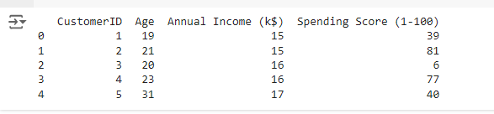

### Plot the dendrogram

import matplotlib.pyplot as plt

from scipy.cluster.hierarchy import dendrogram, linkage def plot_dendrogram(data):

linked = linkage(data, method='ward') # You can change the method here plt.figure(figsize=(10, 7))

dendrogram(linked, orientation='top', distance_sort='descending', show_leaf_counts=True) plt.title('Dendrogram')

plt.xlabel('Sample index') plt.ylabel('Distance') plt.show()

plot_dendrogram(data_normalized)

## OUTPUT:

Ex. 06| Agglomerative Clustering Algorithm

3

**20CS2032L – Machine Learning Techniques**

**URK22AI1048**

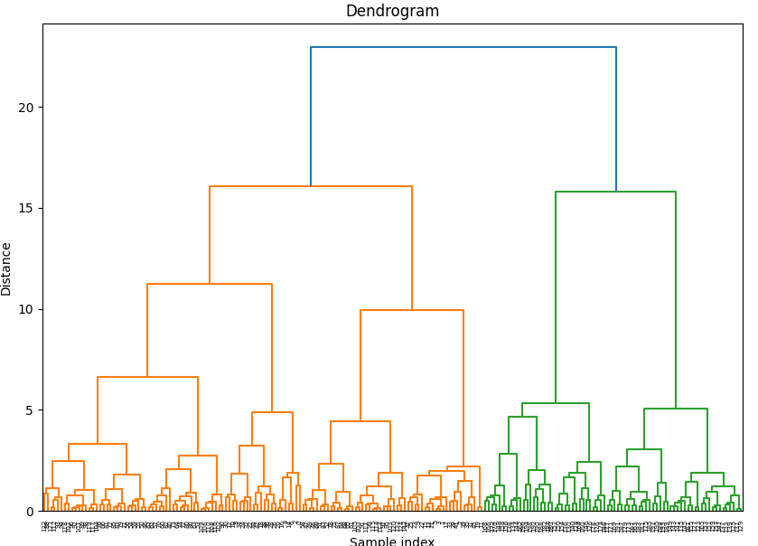

### Implement agglomerative clustering algorithms to cluster the given data for different distance metrics (Euclidean, Manhattan, Cosine, L1, L2) and linkage functions

**(single, complete, average, wards).**

from sklearn.cluster import AgglomerativeClustering distance_metrics = ['euclidean', 'manhattan', 'cosine'] linkage_methods = ['ward', 'single', 'complete', 'average'] results = {}

for metric in distance_metrics:

for linkage_method in linkage_methods:

Ex. 06| Agglomerative Clustering Algorithm

4

**20CS2032L – Machine Learning Techniques**

**URK22AI1048**

if metric == 'cosine' and linkage_method == 'ward': continue # Skip incompatible combinations

try:

clustering = AgglomerativeClustering(n_clusters=3, affinity=metric, linkage=linkage_method)

cluster_labels = clustering.fit_predict(data_normalized) results[(metric, linkage_method)] = cluster_labels

except ValueError as e:

print(f"Error occurred for metric: {metric}, linkage: {linkage_method}") print(e)

## OUTPUT:



### Try with the whole dataset (except the label) and with any 2 attributes

def plot_scatter(data, cluster_labels, title): plt.figure(figsize=(8, 6))

plt.scatter(data[:, 0], data[:, 1], c=cluster_labels, cmap='viridis', marker='o') plt.title(title)

plt.xlabel('Feature 1')

plt.ylabel('Feature 2') plt.show()

for (metric, linkage_method), cluster_labels in results.items():

Ex. 06| Agglomerative Clustering Algorithm

5

**20CS2032L – Machine Learning Techniques**

**URK22AI1048**

plot_scatter(data_normalized[:, :2], cluster_labels, f'Clusters with {metric} and

{linkage_method}')

## OUTPUT:

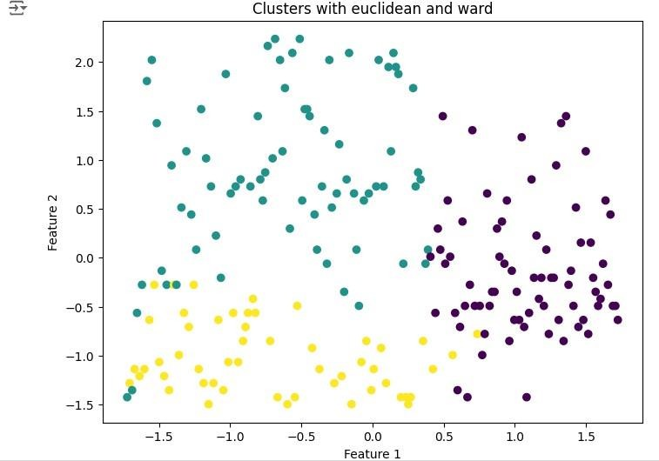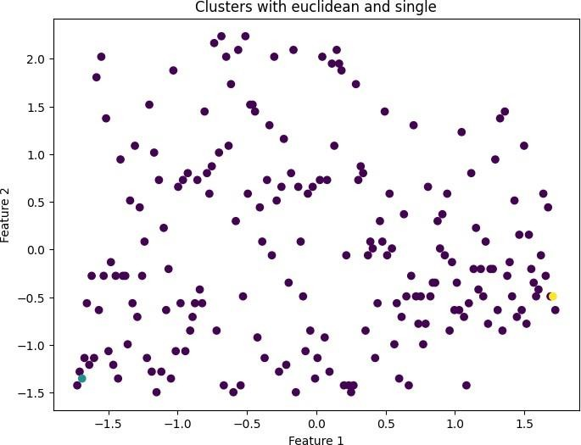

Ex. 06| Agglomerative Clustering Algorithm

6

**20CS2032L – Machine Learning Techniques**

**URK22AI1048**

### Analyse the results using scatter plot

def plot_scatter(data, cluster_labels, title): plt.figure(figsize=(8, 6))

plt.scatter(data[:, 0], data[:, 1], c=cluster_labels, cmap='viridis', marker='o') plt.title(title)

plt.xlabel('Feature 1')

plt.ylabel('Feature 2') plt.show()

## OUTPUT:

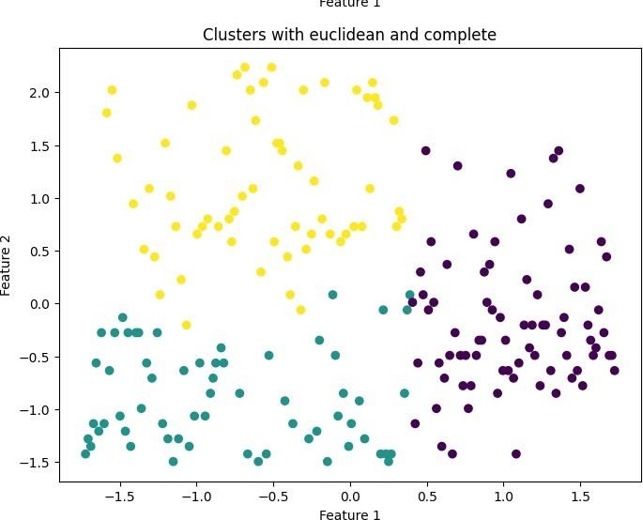

Ex. 06| Agglomerative Clustering Algorithm

7

**20CS2032L – Machine Learning Techniques**

**URK22AI1048**

### Compare the results using Mutual information, Silhouette Score (Silhouette Coefficient), Davies-Bouldin Index.

From sklearn.metrics import silhouette_score, davies_bouldin_score, mutual_info_score true_labels = data['true_label_column_name']

for (metric, linkage_method), cluster_labels in results.items(): silhouette = silhouette_score(data_normalized, cluster_labels)

davies_bouldin = davies_bouldin_score(data_normalized, cluster_labels) mutual_info = mutual_info_score(true_labels, cluster_labels) print(f"Metric: {metric}, Linkage: {linkage_method}") print(f"Silhouette Score: {silhouette:.4f}")

print(f"Davies-Bouldin Index: {davies_bouldin:.4f}")

print(f"Mutual Information: {mutual_info:.4f}") # Uncomment if true labels are available print("-" * 50)

**OUTPUT:**

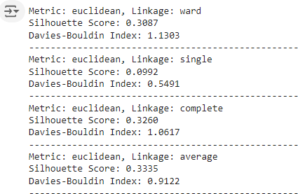

# Result

Agglomerative Clustering Algorithm are executed and verified successfully.

Ex. 06| Agglomerative Clustering Algorithm

8